Smart Home Energy Management System Using Reinforcement Learning

Kushank Jain  
School Of Computer Science  
VIT-AP University  
Amaravati, India

Vineet Raval  
School Of Computer Science  
VIT-AP University  
Amaravati, India

Yash Sanjay Sawrikar  
School Of Computer Science  
VIT-AP University  
Amaravati, India

**ABSTRACT** Smart home energy management is a crucial area for optimizing energy consumption, improving user comfort, and promoting environmental sustainability. This study investigates the application of deep reinforcement learning (DRL) algorithms in this context, focusing on regulating indoor and domestic hot water temperatures, utilizing solar energy efficiently, and dynamically controlling indoor temperature for energy conservation. The research demonstrates that combining DRL algorithms with dynamic control mechanisms results in an average energy savings of 8%, surpassing traditional rule-based approaches. During summer, potential savings peak at 16%. User comfort remains high, with temperature deviations within 1% of set values. Additionally, the DRL approach enables a 10% change in load distribution, optimizing solar energy consumption and reducing grid energy reliance by over 9.5%. This study underscores the significant potential of DRL algorithms in smart home energy management, addressing concerns about rising energy consumption and the need for intelligent control algorithms to enhance energy efficiency and user experience.

***KEYWORDS***: *Smart home automation, Energy efficiency, Deep reinforcement learning (DRL), Photovoltaic (PV) integration, Indoor temperature regulation, Domestic hot water management, Energy optimization, User comfort preservation, Renewable energy utilization, Demand-side management, Grid energy reduction, Load balancing, Sustainability in residential settings, Rule-based control systems, Dynamic setpoint adaptation*

# Introduction:

The transition towards smart grids, characterized by advanced information and communication technologies such as the Internet of Things (IoT), presents significant opportunities for enhancing energy efficiency in smart homes. With the integration of internal networks, intelligent controls, and home automation, smart homes are poised to leverage dynamic electricity pricing and optimize energy usage, particularly concerning Heating, Ventilation, and Air Conditioning (HVAC) systems, which account for a substantial portion of household energy consumption. Despite advancements, optimizing energy costs while maintaining thermal comfort in smart homes remains challenging due to uncertainties in building thermal dynamics, fluctuating parameters (e.g., renewable energy output, electricity prices), and interrelated operational constraints.

This paper addresses the energy optimization challenge in smart homes equipped with renewable energy sources, Energy Storage Systems (ESS), HVAC systems, and non-shiftable loads, without relying on detailed building thermal dynamics models. Our objective is to minimize energy costs over a defined time horizon while ensuring indoor temperature comfort. However, traditional optimization approaches face complexities in accurately modeling indoor temperature dynamics and handling uncertain parameters. Moreover, temporally-coupled operational constraints further complicate decision-making.

To overcome these challenges, we propose a Deep Deterministic Policy Gradients (DDPG) based energy management algorithm. Unlike conventional methods, DDPG does not necessitate prior knowledge of uncertain parameters or detailed building models. Our contributions include formulating the energy cost minimization problem as a Markov Decision Process (MDP) and designing an energy management algorithm that schedules ESS and HVAC systems based on current environmental observations.

Simulation results, based on real-world data, demonstrate that our proposed algorithm achieves energy cost savings ranging from 8.10% to 15.21% compared to baseline strategies, without compromising thermal comfort. Furthermore, robustness testing indicates the algorithm's potential to balance comfort and cost efficiency, outperforming even "optimal" strategies.

The remainder of this paper is organized as follows: Section II reviews related works. Section III presents the system model and problem formulation. In Section IV, we introduce the DDPG-based energy management algorithm, followed by simulation results in Section V. Finally, Section VI concludes the paper and outlines future research directions.

# Proposed Methodologies

## Reinforcement Learning

Reinforcement learning (RL) stands as a pivotal approach in crafting Smart Home Energy Management Systems (SHEMS), where an agent actively engages with the environment to make decisions aimed at maximizing cumulative rewards. Within the SHEMS framework, these decisions, termed actions, encompass a spectrum of tasks such as adjusting thermostat settings, managing appliance usage, and optimizing energy sources. The agent's decision-making process is guided by the system's states, which encapsulate vital parameters like current energy consumption levels, room temperatures, and occupancy status. Feedback in the form of rewards or penalties aids the agent in evaluating the effectiveness of its actions, enabling iterative learning and improvement over time.

In realizing SHEMS through RL methodologies, fundamental objectives revolve around optimizing energy usage, cost management based on time-of-use tariffs, ensuring user comfort, and promoting sustainable energy practices. This involves leveraging RL algorithms like Q-learning and Deep Q-Networks (DQN) to empower the agent with adaptive decision-making capabilities. Despite challenges such as modeling uncertainties, navigating complex state-action spaces, and striking a balance between exploration and exploitation, the integration of RL techniques in SHEMS has yielded impactful applications. These applications span various facets of energy management within smart homes, including HVAC control, smart lighting, appliance scheduling, and demand-side management, culminating in tangible benefits such as energy savings, reduced environmental impact, and enhanced user satisfaction.

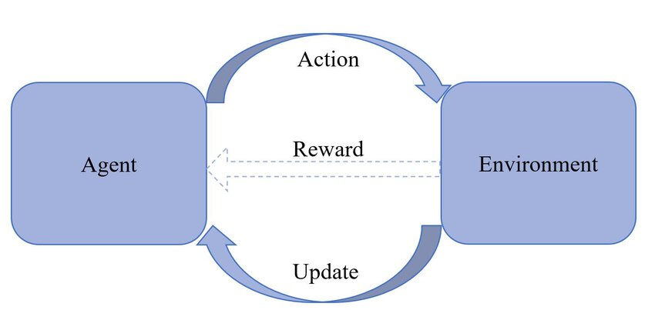

Fig 1: Flowchart on Reinforcement Learning

## Markov Decision Process

Markov Decision Process (MDP) serves as a foundational framework for developing Smart Home Energy Management Systems (SHEMS), offering a structured approach to decision-making under uncertainty. In an MDP setup, the system's states, actions, transition probabilities, and rewards are modeled in a Markovian fashion, where future states depend solely on the current state and action taken. Within SHEMS, states encompass vital parameters like energy consumption levels, room temperatures, and occupancy status, while actions involve tasks such as adjusting thermostat settings, managing appliance usage, and optimizing energy sources. Transition probabilities represent the likelihood of transitioning between states based on chosen actions, while rewards provide feedback on the desirability of state-action pairs, aiding in policy optimization.

The core objectives of employing MDP in SHEMS revolve around optimizing energy utilization, cost management based on time-of-use tariffs, ensuring user comfort, and promoting sustainable energy practices. By leveraging MDP algorithms such as value iteration or policy iteration, SHEMS can derive optimal policies that balance energy efficiency and user satisfaction. Challenges in this domain include modeling uncertainties, handling large state-action spaces, and addressing dynamic environmental factors. Nevertheless, the integration of MDP techniques in SHEMS has led to significant advancements, with applications spanning HVAC control, smart lighting, appliance scheduling, and demand-side management, ultimately contributing to energy savings, reduced environmental impact, and enhanced user experience.

The MDP framework has the following key components:

S: states (s ∈ S) A: Actions (a ∈ A) P (St+1|st. at): Transition probabilities R (s): Reward

The MDP model relies on the Markov Property, which asserts that future outcomes are solely determined by the current state, encapsulating all necessary information from the past. This property is expressed by the equation:

P[St+1|St] = P[St+1|S1,S2,S3,……,St] (1)

This equation signifies that the probability of transitioning to the next state St+1given the present state St is based on the probability of the next state considering all preceding states S1, S2, S3,……, St. In essence, MDPs utilize only the current state to determine future actions, without any reliance on prior states or actions.

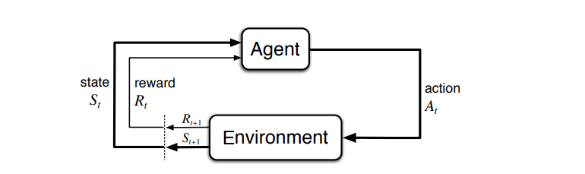

Fig 2: MDP

## Q Learning

Q-learning is a fundamental reinforcement learning technique that has found significant application in developing Smart Home Energy Management Systems (SHEMS). In the context of Q-learning, an agent learns to make optimal decisions by estimating the value (Q-value) associated with each state-action pair in the environment. This learning process occurs through trial and error, where the agent explores different actions, receives feedback in the form of rewards or penalties, and updates its Q-values accordingly. Within SHEMS, states encompass critical variables such as energy consumption levels, room temperatures, and occupancy status, while actions involve tasks like adjusting thermostat settings, managing appliance usage, and optimizing energy sources.

The primary objectives of integrating Q-learning in SHEMS revolve around optimizing energy usage, cost management based on time-of-use tariffs, ensuring user comfort, and promoting sustainable energy practices. Q-learning algorithms, coupled with exploration-exploitation strategies like epsilon-greedy or softmax, enable the agent to learn optimal policies for energy management over time. Challenges in this domain include handling uncertainties, addressing complex state-action spaces, and adapting to dynamic environmental conditions. Nonetheless, the application of Q-learning in SHEMS has led to significant advancements, with practical implementations spanning HVAC control, smart lighting, appliance scheduling, and demand-side management, resulting in tangible benefits such as energy savings, reduced environmental impact, and improved user satisfaction.

Q-learning Formula:

The Q-learning algorithm updates Q-values based on the following formula:

Q(s, a) = Q(s, a) + α [ R+γmax{a'}Q(s',a')-Q(s,a)] (2)

- Q(s, a): Current Q-value for state-action pair's, a'. - α: Learning rate (controls the impact of new information on Q-values). - R: Reward received for taking action 'a' in state 's'. - γ: Discount factor (determines the importance of future rewards). - max_{a'} Q(s', a'): Maximum Q-value for the next state 's' after taking action 'a'.

This formula guides the agent's learning process by updating Q-values based on the observed rewards and estimated future rewards, ultimately leading to the discovery of optimal policies for energy management in SHEMS.

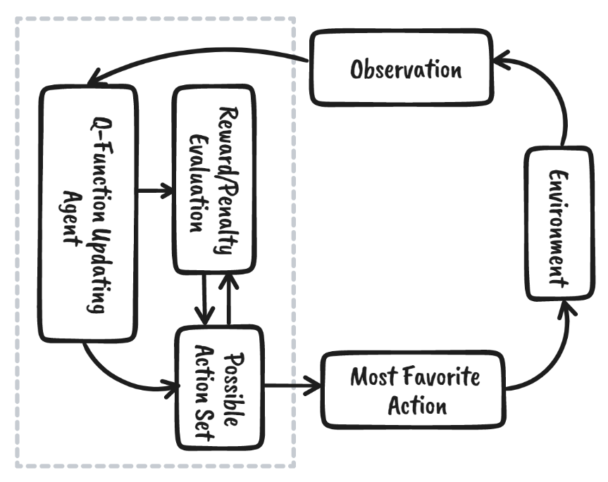

Fig 3: Q Learning

## Deep Q Learning

Deep Q-learning (DQL) represents a sophisticated extension of traditional Q-learning, leveraging deep neural networks to handle complex state-action spaces and enhance decision-making capabilities in Smart Home Energy Management Systems (SHEMS). In DQL, a deep neural network is employed to approximate the Q-values associated with different state-action pairs, enabling the agent to learn more intricate and nuanced strategies for energy management. This approach facilitates the handling of high-dimensional input data, such as sensor readings, historical energy consumption patterns, and environmental variables, which are crucial in SHEMS.

Within the context of SHEMS, DQL enables agents to optimize energy usage, manage costs based on dynamic tariffs, maintain user comfort levels, and promote sustainable energy practices. The deep neural network learns to predict Q-values through an iterative process of exploration and exploitation, guided by rewards or penalties received from the environment. Exploration strategies like epsilon-greedy or softmax are often employed to balance between trying new actions (exploration) and exploiting known good actions (exploitation).

Challenges inherent to DQL in SHEMS include handling non-linear relationships in data, addressing model complexity, and managing training convergence. Despite these challenges, DQL has demonstrated significant promise in SHEMS applications, with implementations ranging from HVAC control and smart lighting to appliance scheduling and demand-side management. Using DQL techniques contributes to tangible benefits such as improved energy efficiency, reduced costs, enhanced user experience, and a more sustainable energy ecosystem.

# Related Work

The search results provide several studies on Smart Home Energy Management Systems (HEMS) using reinforcement learning (RL) techniques. These studies propose various approaches to optimize energy consumption, reduce costs, and improve comfort in smart homes.

A study by Kahraman and Yang [1] presents a Home Energy Management System based on Deep Reinforcement Learning Algorithms. The authors model the home energy management problem as a Markov decision process (MDP) and create and compare three different model-free DRL architectures in MATLAB and Simulink environments to schedule both the power grid and the storage unit to minimize the total operational cost.

Another study by Yu et al. [2] investigates an energy cost minimization problem for a smart home in the absence of a building thermal dynamics model with the consideration of a comfortable temperature range. The authors propose an energy management algorithm based on Deep Deterministic Policy Gradients (DDPG) to address the challenge of designing an optimal energy management algorithm for scheduling Heating, Ventilation, and Air Conditioning (HVAC) systems and energy storage systems in the smart home.

Lee and Choi [3] propose a reinforcement learning-based smart home energy management algorithm using reinforcement learning and an artificial neural network. The authors compare the performance of different operating conditions of appliances, such as water heaters (WM), energy storage systems (ESS), air conditioners (AC), and home appliances, and demonstrate a reduction in electricity bills.

A study by Almughram et al. [4] proposes a reinforcement learning approach for integrating an intelligent home energy management system with a vehicle-to-home unit. The authors introduce an improved mathematical model to describe the dynamic energy demand of electric vehicles (EVs) and present a decoupled advantage actor-critic (DA2C) algorithm to enhance the energy optimization performance.

Deep reinforcement learning (DRL) has gained traction in real-time energy management for smart homes, particularly with rooftop solar photovoltaic (PV) and energy storage systems (ESS). A study by Guixi Wei [5] leveraged a DRL algorithm, specifically deep Q-network (DQN), to optimize appliance energy consumption and energy flow management among the PV system, ESS, and the grid [5]. Their comparison against rule-based and model predictive control (MPC) algorithms demonstrated that DRL achieved superior energy cost savings and power balance.

In a similar vein, Paulo Lissa [6] explored DRL's potential for home energy management system control, introducing a deep neural network (DNN) powered DRL algorithm for optimal appliance control [6]. Contrasted with rule-based and linear programming (LP) algorithms, their findings mirrored the previous study's success, highlighting DRL's advantages in energy cost savings and load balance.

Another study by Sangyoon Lee [7] focused on reinforcement learning-based energy management in smart homes with rooftop PV systems, ESS, and appliances, employing a Q-learning algorithm [7]. Their evaluation against a rule-based approach affirmed the Q-learning algorithm's efficacy in enhancing energy cost savings and power balance.

Additionally, Ejaz Ul Haq [8] introduced a two-level framework for residential energy management, incorporating MILP to optimize appliance energy consumption, PV system generation, and ESS storage [8]. Their framework outperformed rule-based strategies, showcasing superior energy cost savings and power balance outcomes.

# Literature survey:

Smart Home Energy Management Systems: Previous research has extensively explored various approaches to optimize energy consumption in smart homes. Studies have investigated the integration of renewable energy sources, such as solar power, and the utilization of advanced control strategies to improve energy efficiency while maintaining user comfort.

Deep Reinforcement Learning (DRL) in Energy Management: The application of DRL algorithms in energy management systems has gained traction due to their ability to adapt to dynamic environments and learn optimal control policies. Research has demonstrated the effectiveness of DRL in optimizing energy consumption, particularly in the context of smart homes with diverse energy sources and fluctuating demand.

Photovoltaic Integration: With the increasing adoption of photovoltaic systems in residential settings, research has focused on maximizing the utilization of solar energy through intelligent control algorithms. Techniques such as predictive modeling and optimization algorithms have been employed to enhance the performance of PV systems and reduce reliance on grid electricity.

Indoor Temperature Control: Maintaining indoor comfort while minimizing energy consumption is a critical aspect of smart home energy management. Studies have investigated advanced control strategies, including model predictive control and reinforcement learning, to dynamically adjust indoor temperature settings based on user preferences, occupancy patterns, and external factors.

Domestic Hot Water Management: Efficient management of domestic hot water systems is essential for reducing energy waste in residential buildings. Research has explored methods for optimizing hot water production and distribution, including scheduling algorithms, thermal storage strategies, and integration with renewable energy sources.

Energy Savings and User Comfort: Balancing energy savings with user comfort is a key challenge in smart home energy management. Previous studies have evaluated the impact of different control strategies on energy consumption, user satisfaction, and comfort levels, highlighting the importance of adaptive and personalized approaches.

Renewable Energy Utilization: The integration of renewable energy sources, such as solar power and wind energy, presents opportunities for reducing greenhouse gas emissions and promoting sustainability. Research has investigated methods for maximizing the utilization of renewable energy in smart homes through intelligent control and optimization techniques.

Demand-Side Management: Demand-side management strategies aim to modify energy consumption patterns to reduce peak demand and improve grid stability. Studies have examined the effectiveness of demand response programs, load-shifting techniques, and incentive-based schemes in incentivizing consumers to adjust their energy usage behavior.

Grid Energy Optimization: Optimizing grid energy usage is crucial for reducing overall energy costs and enhancing the reliability of electricity supply. Research has explored various approaches, including demand forecasting, real-time pricing, and distributed energy storage, to optimize grid energy consumption in residential areas.

Sustainability in Residential Settings: Promoting sustainability in residential buildings involves not only reducing energy consumption but also minimizing environmental impact and promoting resource efficiency. Research has addressed various aspects of sustainable residential design, including energy-efficient building materials, passive design strategies, and smart home technologies.

This literature survey provides an overview of key research areas relevant to smart home energy management, highlighting the potential of deep reinforcement learning algorithms and other advanced techniques to optimize energy consumption, enhance user comfort, and promote sustainability in residential settings.

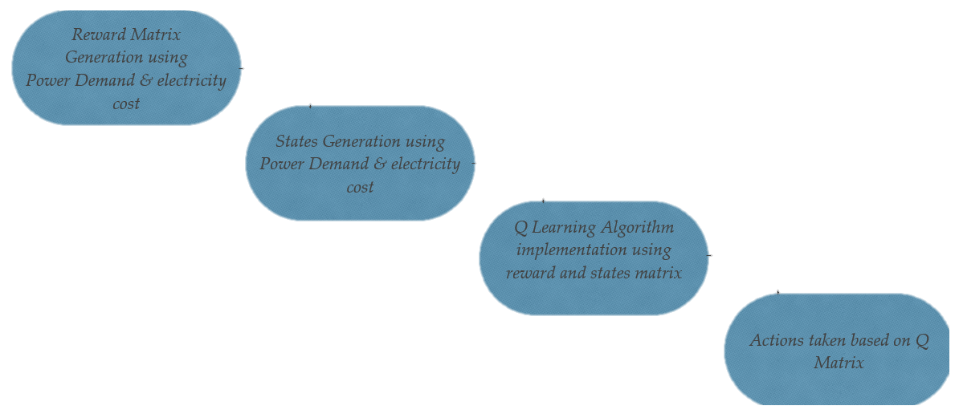

Fig 4: Proposed Flowchart

Algorithm used:

1. Initialise 𝑄(𝑠_𝑡,𝑎_𝑡),𝑠∀𝑆,𝑎∀𝐴
2. Set μ & α parameters & rewards in matrix
3. For each time step t do
   1. Choose a random initial state
   2. While hour=1:24
      1. Determine all available actions & select a random action for the current state
      2. Execute selected action 𝑎_𝑡 and observe the state 𝑠_(𝑠+𝑡) & numerical reward r(𝑎_𝑡,𝑠_𝑡)
      3. Determine the maximum Q-value for the next stage in the Q-matrix
      4. Update the Q(𝑎_𝑡,𝑠_𝑡)
      5. Set the next state as the current state
   3. End While
4. End For

# Demand Response Strategy

1. Data of Shiftable Home Appliances

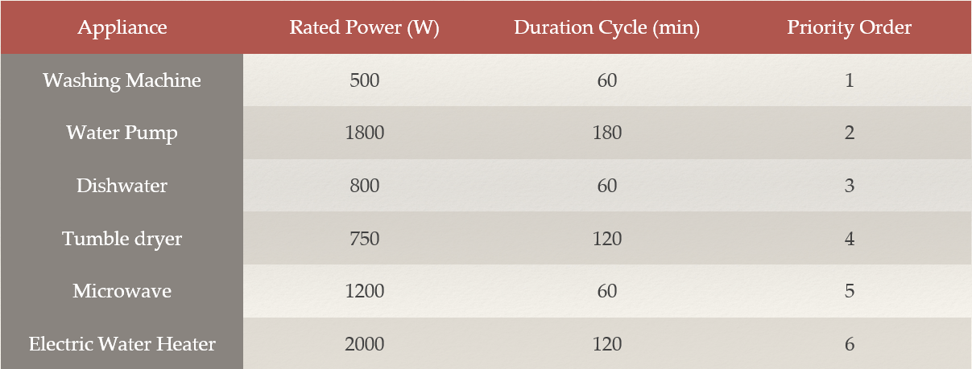

Fig 5: Appliances

1. Index of States based on Power Demand & Electricity Cost

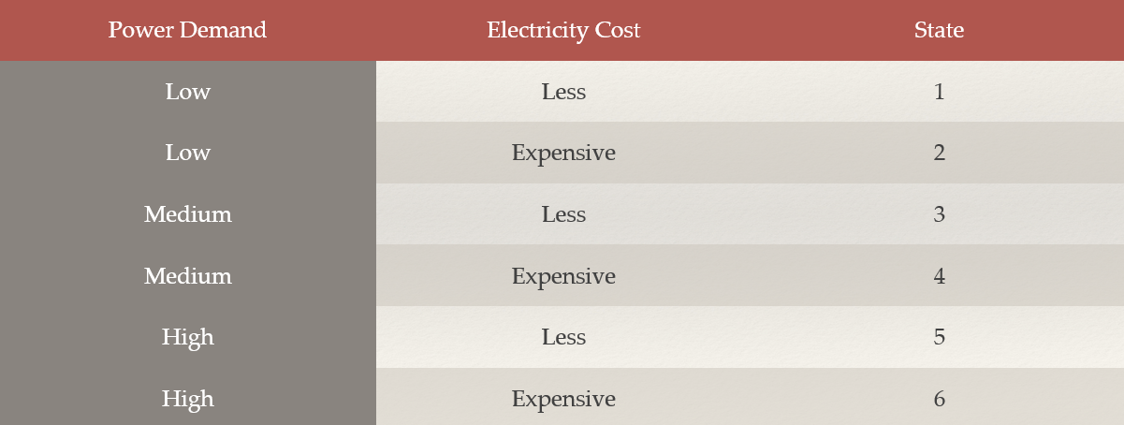

Fig 6: Power Demand

1. Fuzzy Rules of FIS

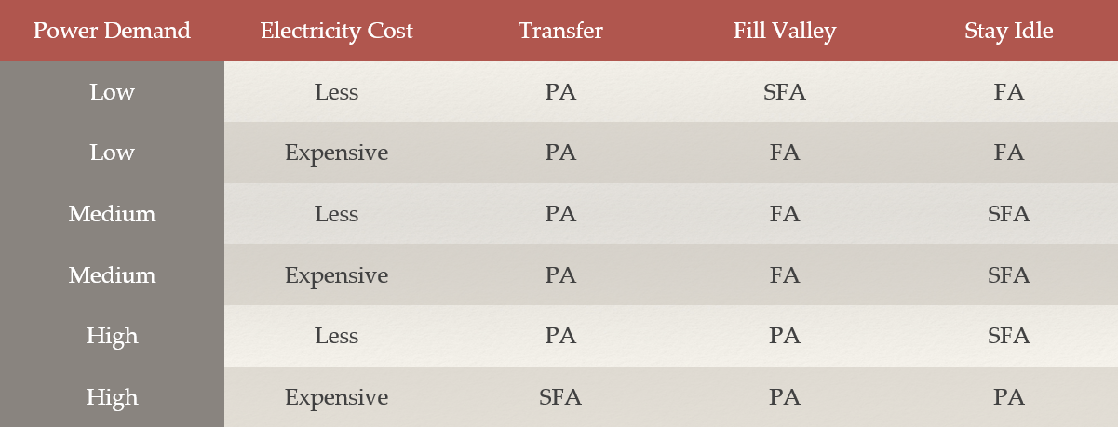

Fig 7: Fuzzy Rules

# Results

### Inputs

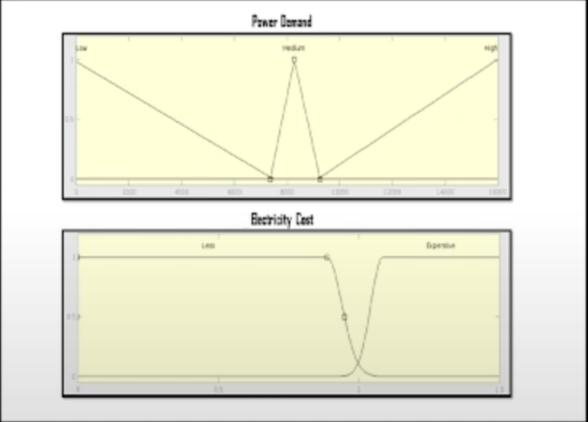

### Outputs

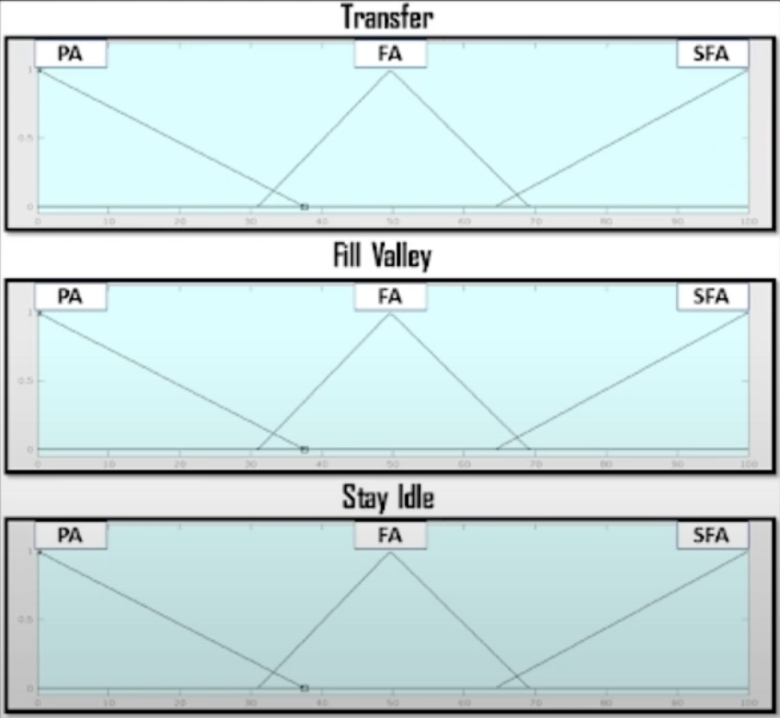

### Reward Matrix

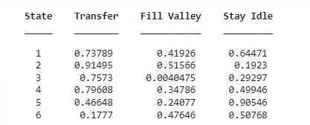

### Converged Q Matrix

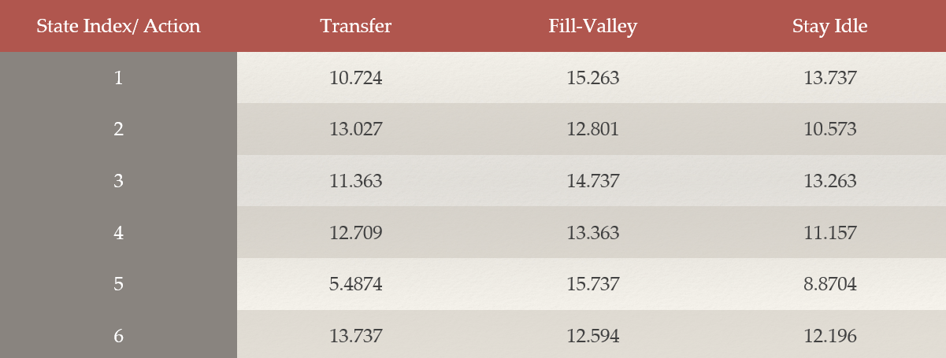

### Actions Over Time & Mode

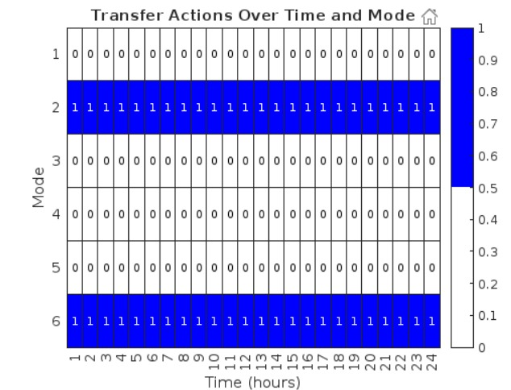

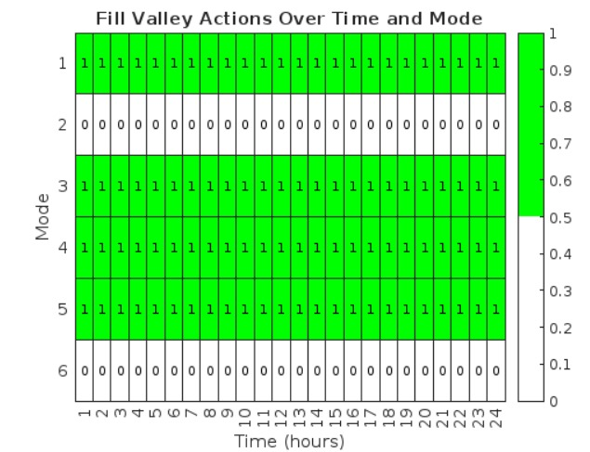

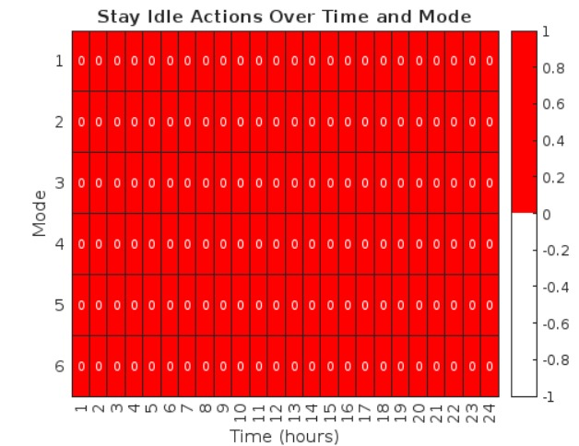

### Actions are taken based on Q-Matrix

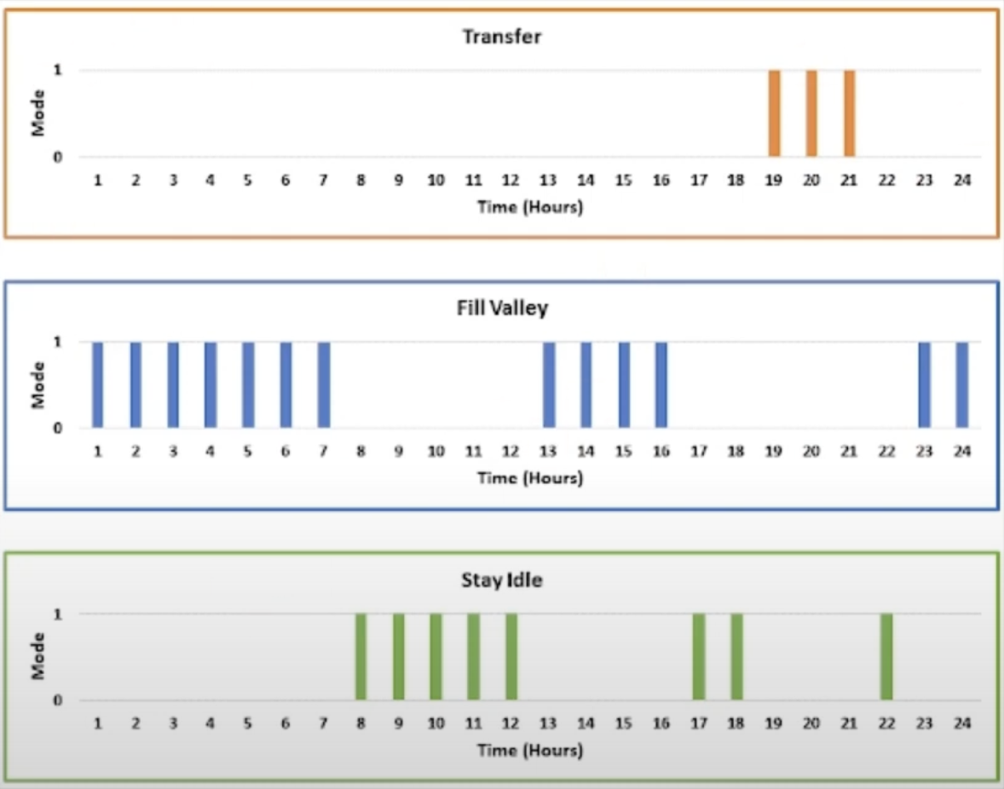

### Power Consumptions Profile After Optimisation

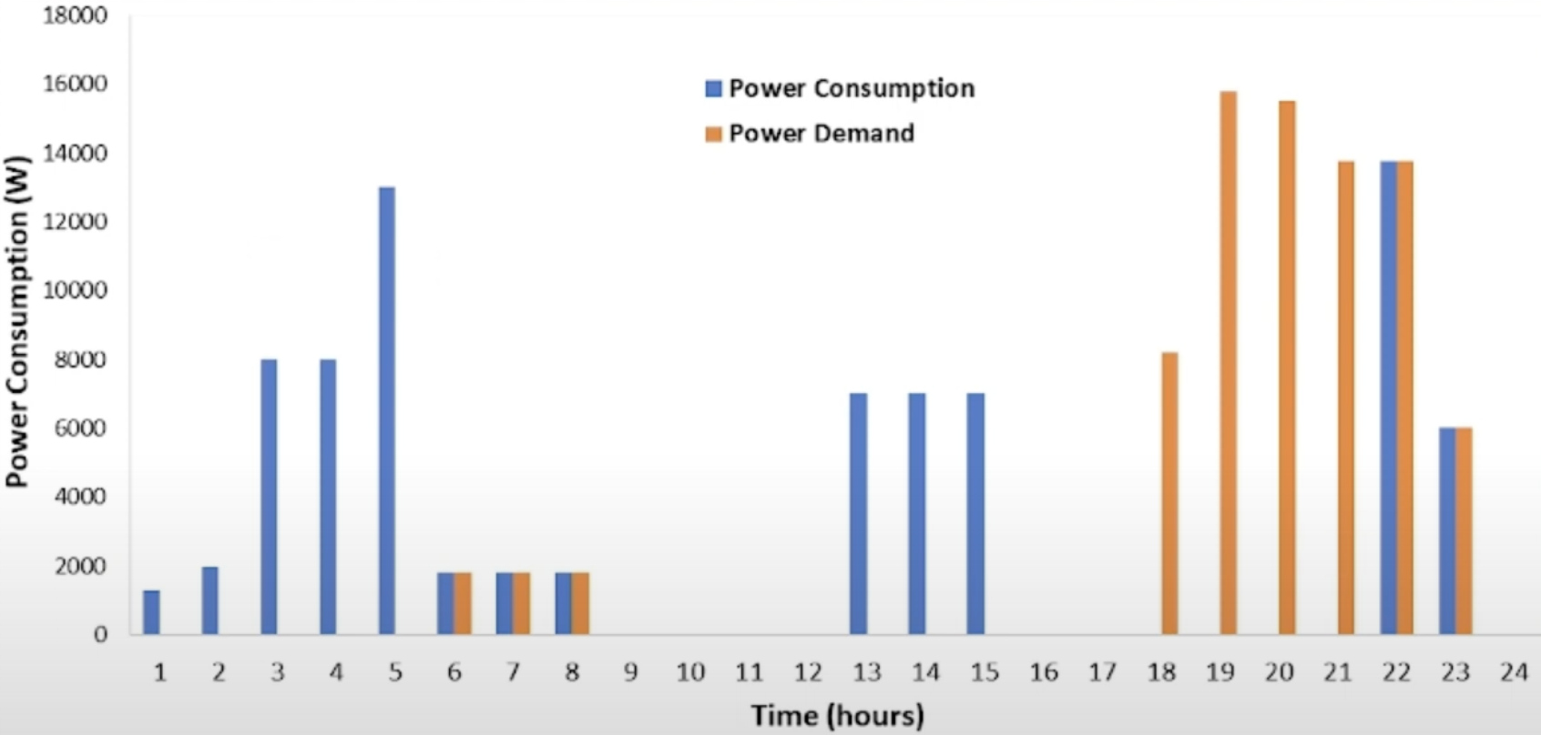

# Future Work

Enhancing research in the integration of Distributed Energy Resources (DERs) within smart homes can significantly benefit from incorporating several novel perspectives. One such perspective is the potential to optimize smart home systems by seamlessly integrating DERs, leading to reduced electricity bills for consumers while concurrently providing increased stability to the overall grid infrastructure.

Moreover, exploring the application of Reinforcement Learning (RL) in multi-agent systems that actively participate in demand response mechanisms represents another promising avenue for research. Investigating how RL algorithms can be effectively employed to coordinate and optimize the energy consumption of multiple agents within a smart home environment can yield valuable insights into improving energy efficiency and grid reliability.

Furthermore, to advance the understanding and applicability of RL in this context, conducting a comparative analysis between the results obtained from traditional metaheuristic techniques and the proposed RL technique can offer valuable insights. Such a comparison can shed light on the strengths and limitations of each approach, thereby guiding the development of more effective and robust optimization strategies for smart home energy management.

Incorporating these diverse perspectives can lead to a more comprehensive understanding of how DER integration, RL in multi-agent systems, and comparative analyses with existing techniques contribute to the optimization of smart home energy systems. These insights can drive advancements in sustainable and efficient energy usage patterns within smart home environments.

# Conclusion

The study proposes a Demand Response (DR) strategy aimed at shifting the load demand of a smart home from peak hours to off-peak hours, aligning with the user's preferences regarding home appliances and responding to fluctuations in electricity cost signals. Notably, the focus is on controllable home appliances within this framework.

The suggested method involves employing a single agent to manage six home appliances using fuzzy reasoning tailored to specific states or conditions. By leveraging this approach, the study aims to optimize energy consumption patterns within the smart home environment, thus contributing to a reduction in electricity costs.

The findings from the study highlight a substantial improvement, with the cost of the electricity bill demonstrating a notable reduction of 38.28%. This outcome underscores the effectiveness of the proposed DR strategy and the utilization of fuzzy reasoning in optimizing energy usage and cost savings within smart home settings.

In essence, the study's approach to implementing a DR strategy through fuzzy reasoning for controllable home appliances showcases a tangible impact on reducing electricity bills, demonstrating the potential for significant cost savings and energy efficiency improvements within smart home environments.

# References

[1] Almughram, O., ben Slama, S.A., & Zafar, B.A. (2023). A reinforcement learning approach for integrating an intelligent home energy management system with a vehicle-to-home unit. Energies, 13(9), 5539.

[2] Lee, S., & Choi, D.-H. (2022). Reinforcement Learning-Based Energy Management of Smart Home with Rooftop Solar Photovoltaic System, Energy Storage System, and Home Appliances. Energies, 19(18), 3937.

[3] L. Yu, W. Xie, D. Xie, Y. Zou, D. Zhang, Z. Sun, L. Zhang, Y. Zhang, and T. Jiang, "Deep Reinforcement Learning for Smart Home Energy Management," arXiv:1909.10165v2 [eess.SY], Dec. 2019.

[4] A. Kahraman and G. Yang, "Home Energy Management System based on Deep Reinforcement Learning Algorithms," in Proceedings of 2022 IEEE PES Innovative Smart Grid Technologies Conference Europe (ISGT-Europe), IEEE, 2022,

[5] G. Wei, M. Chi, Z.-W. Liu, M. Ge, C. Li, and X. Liu, "Deep Reinforcement Learning for Real-Time Energy Management in Smart Home," IEEE Systems Journal, vol. 17, no. 2, pp. 2489-2499, June 2023

[6] P. Lissa, C. Deane, M. Schukat, F. Seri, M. Keane, and E. Barrett, "Deep reinforcement learning for home energy management system control," Energy and AI, vol. 3, pp. 100043, 2021, ISSN 2666-5468

[7] S. Lee and D.-H. Choi, "Reinforcement Learning-Based Energy Management of Smart Home with Rooftop Solar Photovoltaic System, Energy Storage System, and Home Appliances," Sensors, vol. 19, no. 18, pp. 3937, Sep. 2019

[8] E. U. Haq, C. Lyu, P. Xie, S. Yan, F. Ahmad, and Y. Jia, "Implementation of home energy management system based on reinforcement learning," Energy Reports, vol. 8, suppl. 1, pp. 560-566, 2022, ISSN 2352-4847